June 2016 |  | Baccalaureate  Is a Church service in honour of the Grads of 2016, that family members are invited to attend.  Prom  Family and community members are invited to watch the Grads enter the prom along the roped off path.  Grad Dinner/ Academic Awards  A Grads only catered formal dinner is held at SRHS prior to the Academic Awards. Family and friends are invited to join their Grads for the Awards in the theatre.  Graduation  All Grads march together to the 8th Hussars. Grads will receive their diplomas, there will be special guest speakers, the valedictorian will be recognized, and bursaries and scholarships will be awarded.  Safe Grad  Safe Grad is for Grads only and  begins following Graduation. This is  a supervised, alcohol and drug free  event. All Grads are encouraged to  participate.

Sunday | Monday | Tuesday | Wednesday | Thursday | Friday | Saturday
 |  |  | 1 | 2 | 3 | 4
Activity Awards
6:30pm in the SRHS Theatre
5 | 6 | 7 | 8 | 9 | 10 | 11
12 | 13 | 14 | 15 | 16 | 17 | 18
 | Period 1 Exam | Period 2 Exam | Period 3 Exam | Period 4 Exam | Period 5 Exam
19 | 20 | 21 | 22 | 23 | 24 | 25
Baccalaureate Service 5:45pm (SRHS) for 7pm at the Saunders Irving Chapel |  | Prom  7:45pm arrival  8 – 10pm  at SRHS | Grad Dinner 5:30pm at SRHS  Grad Academic Awards 7pm  at SRHS | Rehearsal 10am at 8th Hussars  Graduation 5:30pm for 7pm at SRHS  Safe Grad | Report Card pick-up
26 | 27 | 28 | 29 | 30

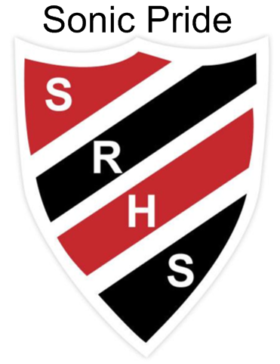
SUSSEX REGIONAL HIGH SCHOOL GRADUATION 2016

Need to know:

- Exams will be written the week of June 13-17.

- All graduation events are school activities and therefore school rules apply.

- Basic graduation fee of $30.00 must be paid by all graduates. This fee covers the cost of diploma covers, cap, tassel, dry cleaning gowns, programs, invitations, postage for transcripts, etc.

- All fees associated with graduation will be collected in the lobby by Grad Class beginning May 9, 2016
(CASH ONLY & RECEIPTS PROVIDED).

- Any student, who will not graduate, will be notified by Principal Wall on the morning of Wednesday, June 22nd.

- Graduates that are attending post-secondary institutions in the fall are reminded that it is necessary to complete the “transcript request” form in the school office in order for their final marks to be sent to the college/university they have chosen to attend.

- Graduation is an expensive time for all families. We have some funds available to help any graduate in need at this time of year (for clothing, fees, etc.). Graduates or parents may confidentially contact Mr.Robertson or Mrs. Laird in the Guidance Office if you find yourself in this situation.

Graduation Events:

- Baccalaureate Service – 7 p.m. June 19th, Saunders Irving Chapel @ Kingswood University, 20 Wesley Drive
Graduates and parents are encouraged to attend this church service.
Recommended dress is semi-formal/ business causal: This would be similar to how you would dress for a class presentation. Comfortable shoes are recommended as students march from SRHS to the church.
Students should be at the school by 5:45 p.m.to allow time for the grad march through town.

- Graduation Prom – 8 – 10:00 p.m. June 21st, SRHS Cost $15/Grad
Graduates are to meet at the 8th Hussars at 6:00 p.m. for a group photo.
Graduates are to arrive at the school before 7:45 p.m.

- Grad Dinner - 5:30 p.m. June 22nd, SRHS Cost $25/Grad & Awards Night – 7 p.m. June 22nd Theatre SRHS
Grads only enjoy a meal catered by the Chef’s Table. Following the dinner, Grads and parents are invited awards and class prizes (that are not presented at graduation). Teacher advisor for the Grad Dinner is Mrs. Gillies.

- Graduation rehearsal - 10 a.m. June 23rd, 8TH Hussars Sports Centre.
Students will be shown how to enter the rink, how to receive their diploma and practice the process.
It is at this time that extra floor tickets will be handed out to graduates.

- Graduation – 7 p.m. June 23rd, 8th Hussars Sports Centre
Each graduate receives 3 invitations for the main floor only from the office once they have paid their Grad fee. The bleachers do not require invitations. Graduates should arrive at the school at 5:30 p.m. to have their cap and gown fitted by teachers and parent volunteers. Dress is formal for graduation, with gentlemen wearing white shirts and a dark or red tie, dark pants and shoes. Ladies wear should be a white shirt or blouse, dark pants or skirt and dark shoes.
After graduation, gowns are to be returned to the school.

- Safe Grad – Immediately following Graduation, June 23rd, Cost $30/Grad
This is drug and alcohol free party planned for graduates only. We will leave for Camp Tulakadik shortly after the graduation ceremony. Safe Grad will run from approximately 10 p.m. - 7 a.m. so dress in layers. Some of the activities include video & board games, movies, music, Lip Sync Battle, crafts, beach volleyball, campfire, capture the flag, night games and more. Breakfast will be provided before returning to the school.

Should you have any questions regarding these events or activities, please feel free to contact SRHS @ 432-2017

